**Improvement**

1. It will be better before give “course count” we could choose which course we want. Like have a field with courses name and select it before “course count” field.
2. All fields name should written on bold and on scope. Then all fields name should be uppercase.
3. After submission “Courses discount” on “Courses” field should be visible discounted courses.
4. Admin user should navigate his/her profile page and “Discount Changes” should be visible, but it is not clear what can include profile page. On Application it is called “User_Action”.
5. It will be better change “Discount Changes” button’s name because with screen name they are the same.

**Requirement Analyze**

1. Admin user should navigate “User_Action” after that “Change Discount” can be visible.
2. After submission admin see “Discount changes”, which isn’t a notification, it can be a success message.
3. Expanded the steps in the acceptance criteria to provide a clear, step-by-step workflow.
4. Specified the type of input fields (numeric, dropdown list) to avoid ambiguity.

**Bug Report 1**

|  |  |  |
| --- | --- | --- |
| ID number | #1 | *automatically getting in bug tracking system* |
| Bug Summary | Discount field accept letters and symbols |  |
| Reporter | Ani Etibaryan |
| Submit Date | 07/06/2024 | *automatically getting in bug tracking system* |
| Platform | Macintosh |  |
| Operating System | macOS (Catalina) 10.15.7 |  |
| Browser | Chrome 124 |  |
| Severity | High |  |
| Priority | High |  |
| Status | new | *automatically getting ‘Open’ in bug tracking system* |
| Assigned to | QA/Developer/BA |  |
| Version | 1.0 |  |
| Environment | test |  |
| Component/tag |  |  |
| Screenshot/video |  |  |

**Precondition**:

1. To have access [**https://qwallity-exam.onrender.com/**](https://qwallity-exam.onrender.com/)
2. Email: [qwallitymanual16042024@gmail.com](mailto:qwallitymanual16042024@gmail.com)
3. Code: qwallity16042024#
4. Login as Admin user: Login: admin-user
5. Password: 11111111

**Description:**

Discount field should be only numeric

**Steps to reproduce**

1. Go to User_Action
2. Click on Change Discount button
3. Choose some course type (Advanced or Fundamental)
4. Put letters and symbols on “discount” field
5. Click on “Change Discount” button

**Actual result**

“Discount is changed” success message appeared

**Expected result**

The system should not give access and it will be better give warning message that discount field is only numeric

**References:**

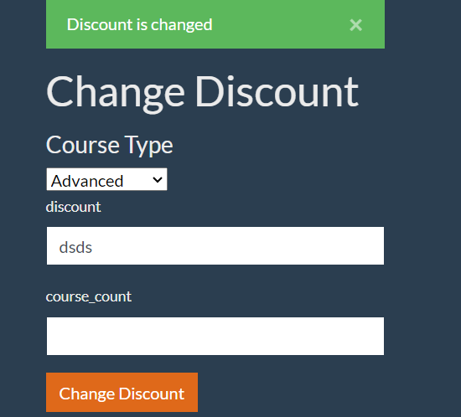

**Bug Report 2**

|  |  |  |
| --- | --- | --- |
| ID number | #2 | *automatically getting in bug tracking system* |
| Bug Summary | “Course Count” field accept letters and symbols |  |
| Reporter | Ani Etibaryan |
| Submit Date | 07/06/2024 | *automatically getting in bug tracking system* |
| Platform | Macintosh |  |
| Operating System | macOS (Catalina) 10.15.7 |  |
| Browser | Chrome 124 |  |
| Severity | High |  |
| Priority | High |  |
| Status | new | *automatically getting ‘Open’ in bug tracking system* |
| Assigned to | QA/Developer/BA |  |
| Version | 1.0 |  |
| Environment | test |  |
| Component/tag |  |  |
| Screenshot/video |  |  |

**Precondition**:

1. To have access [**https://qwallity-exam.onrender.com/**](https://qwallity-exam.onrender.com/)
2. Email: [qwallitymanual16042024@gmail.com](mailto:qwallitymanual16042024@gmail.com)
3. Code: qwallity16042024#
4. Login as Admin user: Login: admin-user
5. Password: 11111111

**Description:**

“Course_Count” field should be only numeric

**Steps to reproduce**

1. Go to User_Action
2. Click on Change Discount button
3. Choose some course type (Advanced or Fundamental)
4. Put letters and symbols on “course_count” field
5. Click on “Change Discount” button

**Actual result**

“Discount is changed” success message appeared

**Expected result**

The system should not give access and it will be better give warning message that discount field is only numeric

**References:**

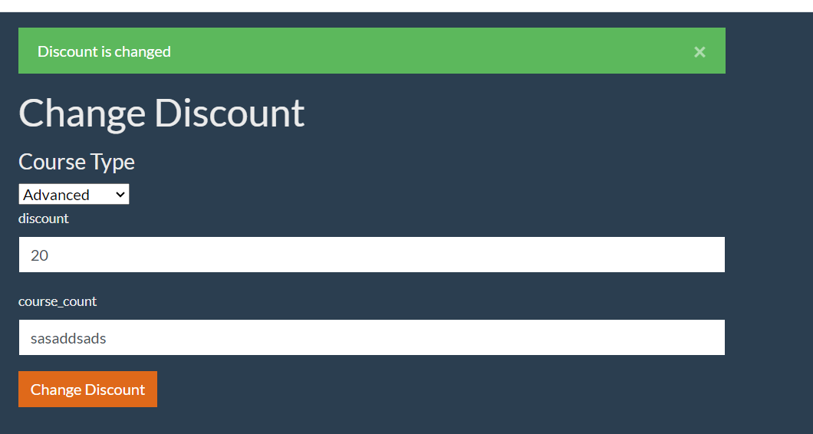

**Bug Report 3**

|  |  |  |
| --- | --- | --- |
| ID number | #3 | *automatically getting in bug tracking system* |
| Bug Summary | “Course Count” and “discount” fields can be submitted with empty data |  |
| Reporter | Ani Etibaryan |
| Submit Date | 07/06/2024 | *automatically getting in bug tracking system* |
| Platform | Macintosh |  |
| Operating System | macOS (Catalina) 10.15.7 |  |
| Browser | Chrome 124 |  |
| Severity | High |  |
| Priority | High |  |
| Status | new | *automatically getting ‘Open’ in bug tracking system* |
| Assigned to | QA/Developer/BA |  |
| Version | 1.0 |  |
| Environment | test |  |
| Component/tag |  |  |
| Screenshot/video |  |  |

**Precondition**:

1. To have access [**https://qwallity-exam.onrender.com/**](https://qwallity-exam.onrender.com/)
2. Email: [qwallitymanual16042024@gmail.com](mailto:qwallitymanual16042024@gmail.com)
3. Code: qwallity16042024#
4. Login as Admin user: Login: admin-user
5. Password: 11111111

**Description:**

“Course_Count” and “discount” fields should contain valid data(numeric)

**Steps to reproduce**

1. Go to User_Action
2. Click on Change Discount button
3. Choose some course type (Advanced or Fundamental)
4. Leave “course_count” and “discount” fields empty
5. Click on “Change Discount” button

**Actual result**

“Discount is changed” success message appeared

**Expected result**

The system should not accept successfully

**References:**

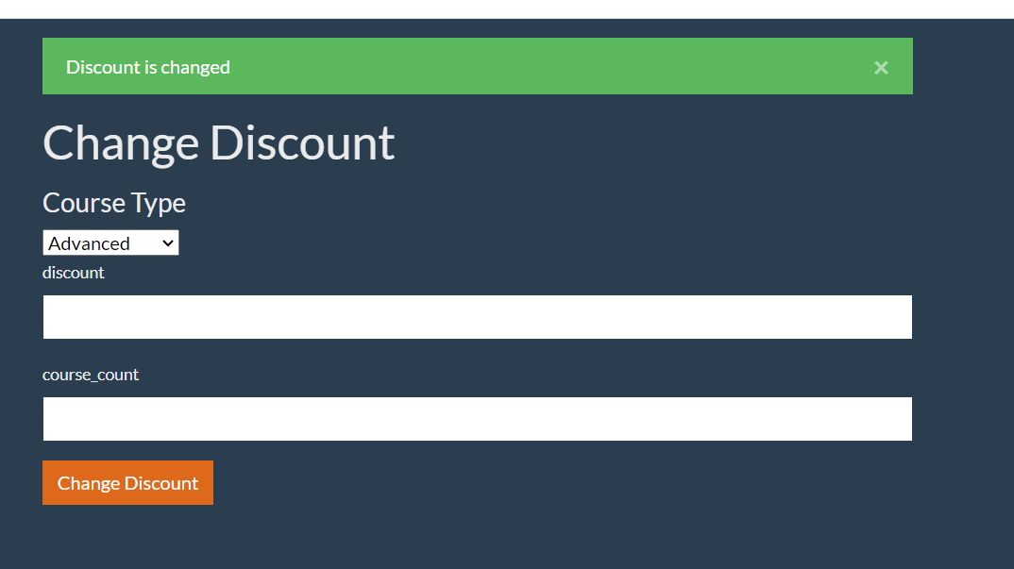

**Bug Report 4**

|  |  |  |
| --- | --- | --- |
| ID number | #4 | *automatically getting in bug tracking system* |
| Bug Summary | “Discount changes” message isn’t correct |  |
| Reporter | Ani Etibaryan |
| Submit Date | 07/06/2024 | *automatically getting in bug tracking system* |
| Platform | Macintosh |  |
| Operating System | macOS (Catalina) 10.15.7 |  |
| Browser | Chrome 124 |  |
| Severity | Low |  |
| Priority | Low |  |
| Status | new | *automatically getting ‘Open’ in bug tracking system* |
| Assigned to | QA/Developer/BA |  |
| Version | 1.0 |  |
| Environment | test |  |
| Component/tag |  |  |
| Screenshot/video |  |

**Precondition**:

1. To have access [**https://qwallity-exam.onrender.com/**](https://qwallity-exam.onrender.com/)
2. Email: [qwallitymanual16042024@gmail.com](mailto:qwallitymanual16042024@gmail.com)
3. Code: qwallity16042024#
4. Login as Admin user: Login: admin-user
5. Password: 11111111

**Steps to reproduce**

1. Go to User_Action
2. Click on Change Discount button
3. Choose some course type (Advanced or Fundamental)
4. Fill fields Discount and Course_Count with valid data
5. Click on “Change Discount” button

**Actual result**

“Discount is changed” success message appeared

**Expected result**

It should be “Discount changes” message.

**References:**



**Bug Report 5**

|  |  |  |
| --- | --- | --- |
| ID number | #5 | *automatically getting in bug tracking system* |
| Bug Summary | For Non-Admin user is not visible discounted courses which configured by Admin user |  |
| Reporter | Ani Etibaryan |
| Submit Date | 07/06/2024 | *automatically getting in bug tracking system* |
| Platform | Macintosh |  |
| Operating System | macOS (Catalina) 10.15.7 |  |
| Browser | Chrome 124 |  |
| Severity | Low |  |
| Priority | Low |  |
| Status | new | *automatically getting ‘Open’ in bug tracking system* |
| Assigned to | QA/Developer/BA |  |
| Version | 1.0 |  |
| Environment | test |  |
| Component/tag |  |  |
| Screenshot/video |  |

**Precondition**:

1. To have access [**https://qwallity-exam.onrender.com/**](https://qwallity-exam.onrender.com/)
2. Email: [qwallitymanual16042024@gmail.com](mailto:qwallitymanual16042024@gmail.com)
3. Code: qwallity16042024#
4. Login as Non-Admin user: Login: AniEtibaryan
5. Password: 12345678

**Description:**

When non-admin user wants to buy some course,discounted course isn’t visible.

**Steps to reproduce**

1. Go to User_Action
2. Choose some course type (Advanced or Fundamental)
3. Watch Courses detail.

**Actual result**

Discounted courses isn’t visible for non-admin user

**Expected result**

Price should be shown already discounted (take into account admin configuration).

And give notification: ’*You have xxx discount. Discounted price displays.’*